**Forward and Backward Propogation**

**Q1. What is the purpose of forward propagation in a neural network?**

**Purpose of Forward Propagation in a Neural Network**

**Forward propagation** is the process by which inputs pass through a neural network to produce an output. Its primary purpose is to calculate the predicted output of the network given the input data.

**Key Objectives:**

1. **Compute the Output**:
   * Forward propagation computes the output of the network based on the weights, biases, and activation functions for each layer.
   * For a classification task, this could be a class label, and for regression, it could be a continuous value.
2. **Feed Data Through the Layers**:
   * Each layer in the network transforms the input data by applying linear transformations (weights and biases) followed by non-linear activation functions.
3. 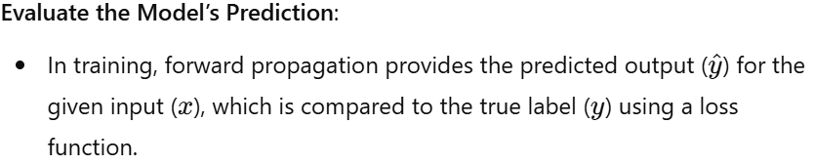

**Serve as a Basis for Backpropagation**:

* Forward propagation is the first step in the training process. The output generated is used to compute the loss, which is then backpropagated to update the model parameters.

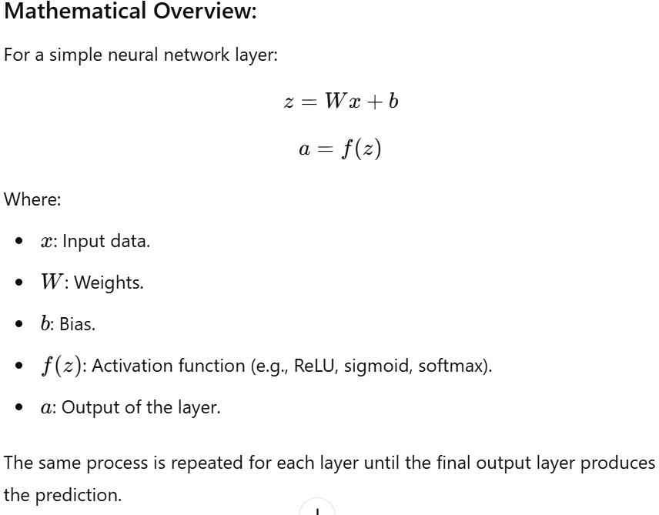

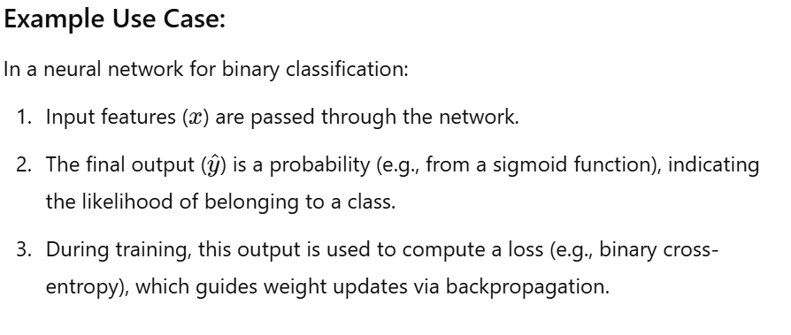

**Q2. How is forward propagation implemented mathematically in a single-layer feedforward neural network?**

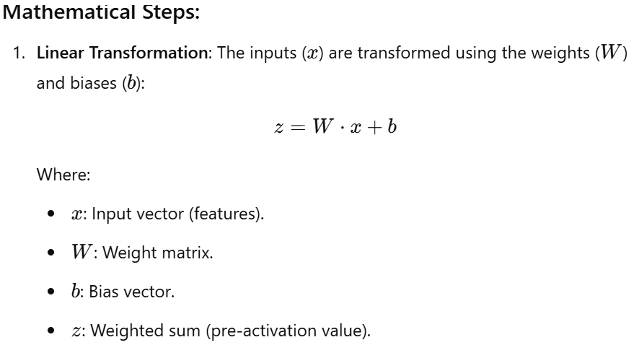

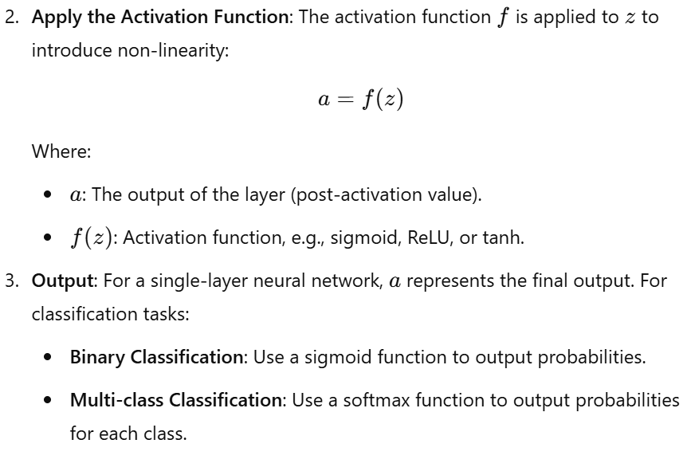

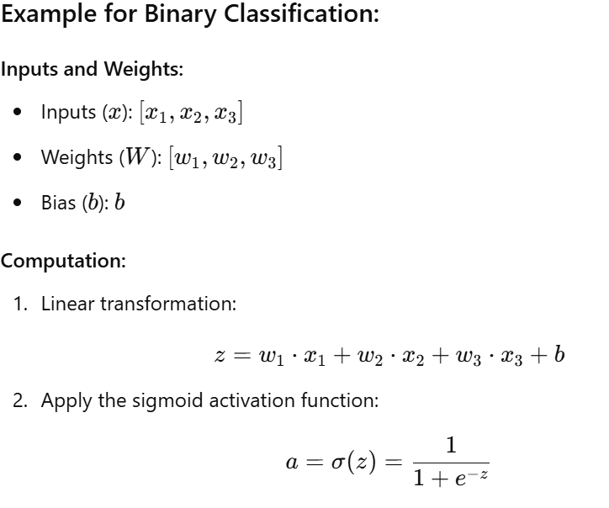

**Final Output:**

The output aaa is a probability between 0 and 1, indicating the likelihood of belonging to the positive class.

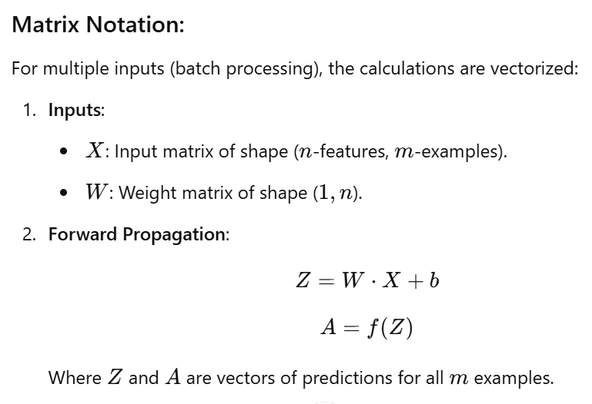

**Q3. How are activation functions used during forward propagation?**

**Role of Activation Functions During Forward Propagation**

**Activation functions** are applied during forward propagation to introduce **non-linearity** into the neural network. Without activation functions, a neural network would behave like a linear model, regardless of its depth, and would not be able to learn complex patterns.

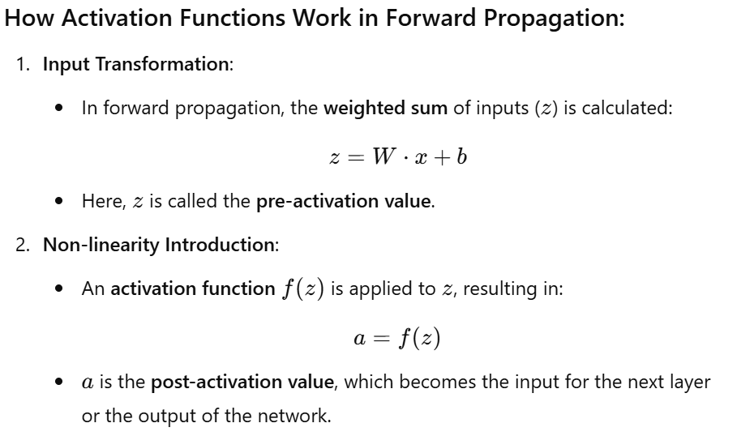

**Propagation to the Next Layer**:

* The activation function ensures that the network can learn non-linear relationships, enabling it to model complex patterns.

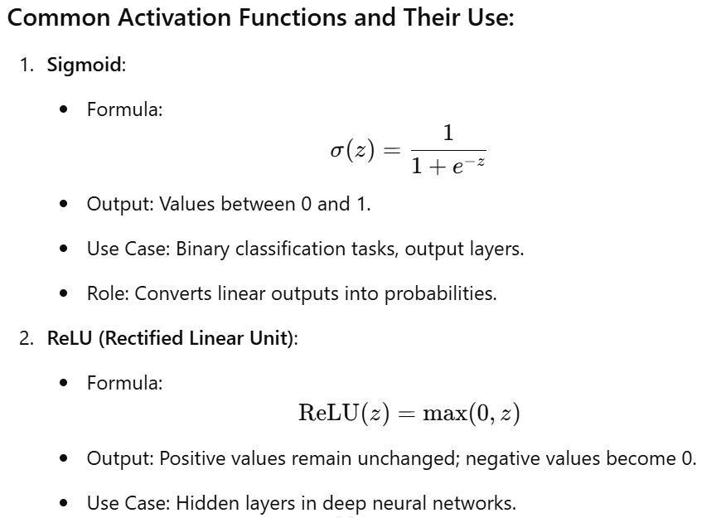

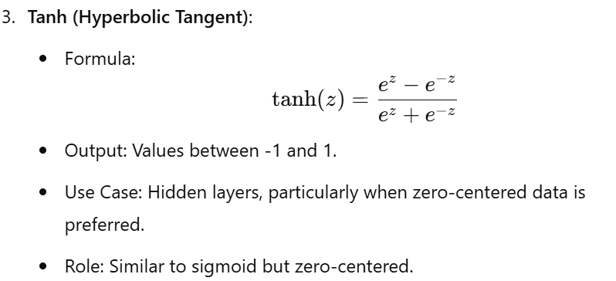

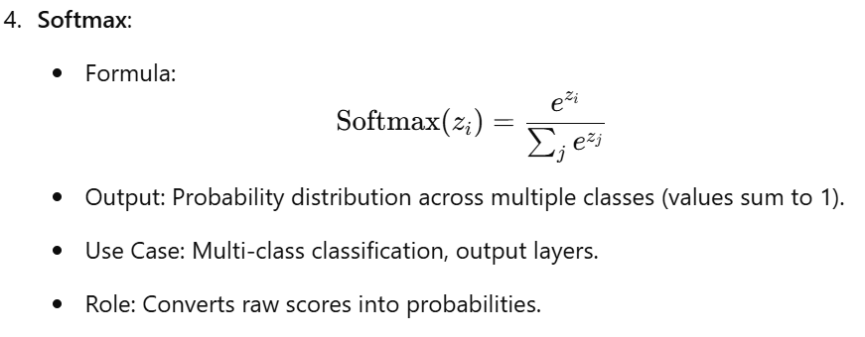

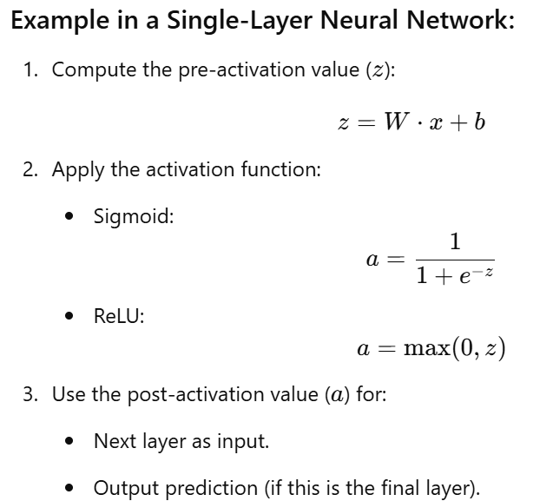

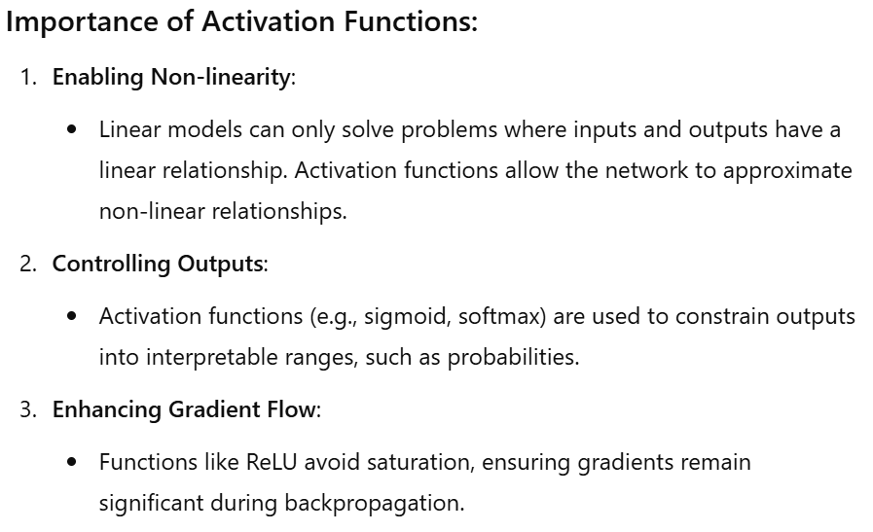

**Q4. What is the role of weights and biases in forward propagation?**

**Role of Weights and Biases in Forward Propagation**

Weights and biases are fundamental components of a neural network, and their primary role in forward propagation is to transform the input data into meaningful outputs that the network can use for learning and predictions.

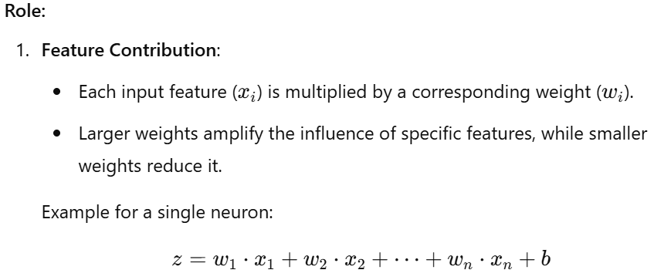

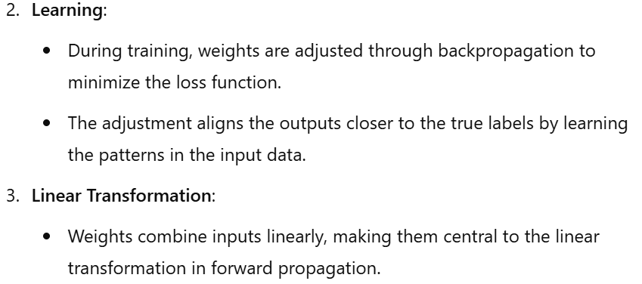

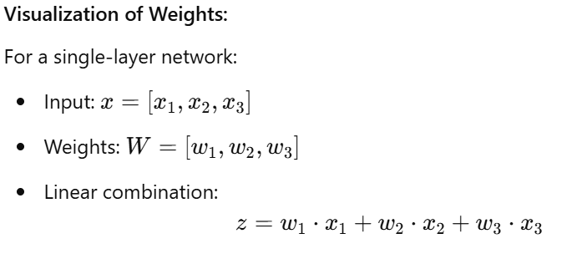

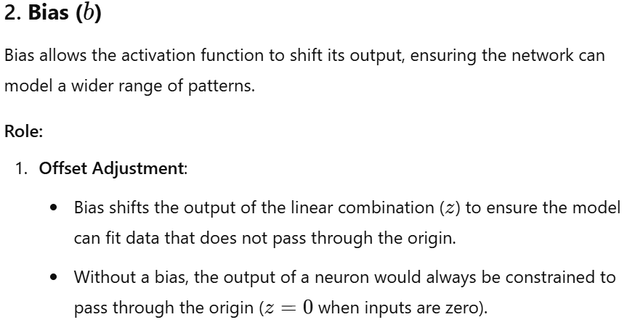

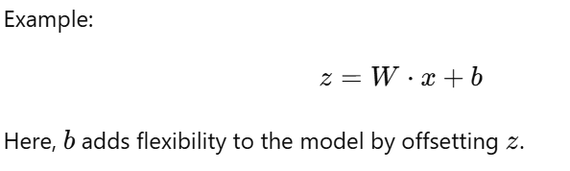

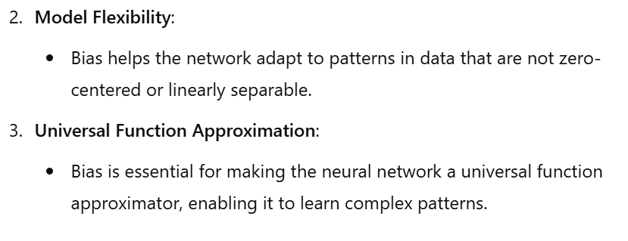

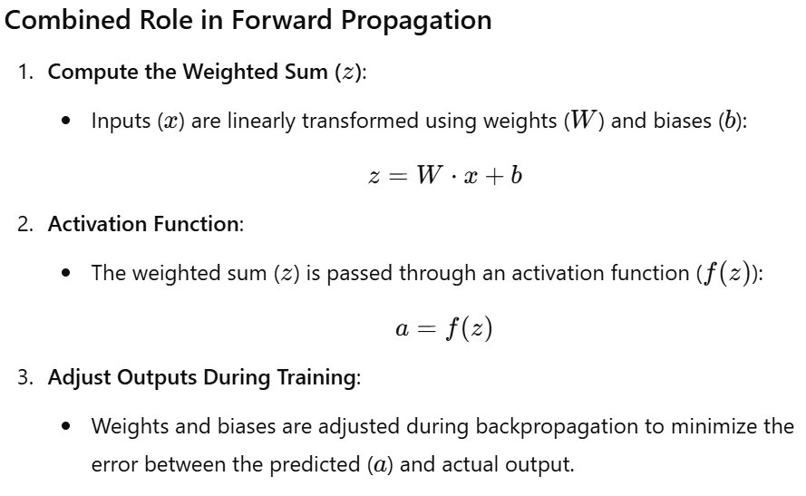

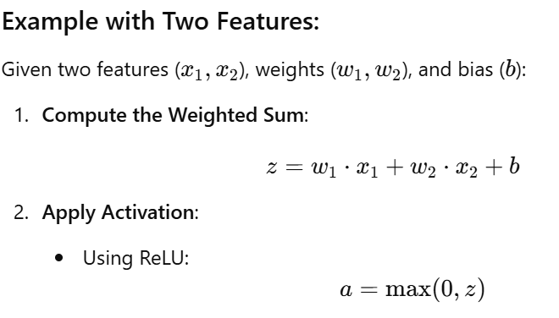

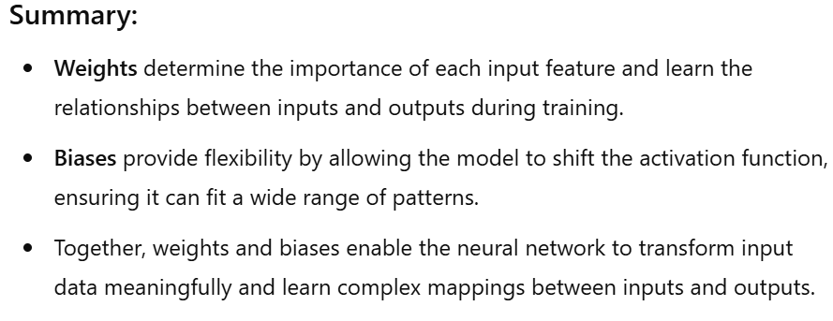

**Q5. What is the purpose of applying a softmax function in the output layer during forward propagation?**

**Purpose of Applying the Softmax Function in the Output Layer**

The softmax function is used in the output layer of a neural network for multi-class classification tasks. Its primary purpose is to convert raw output scores (logits) into a probability distribution over all possible classes.

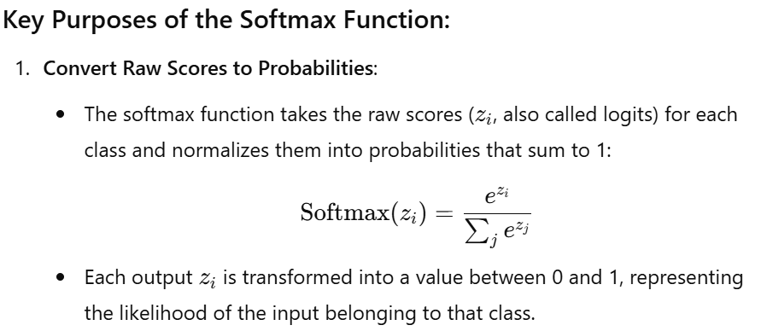

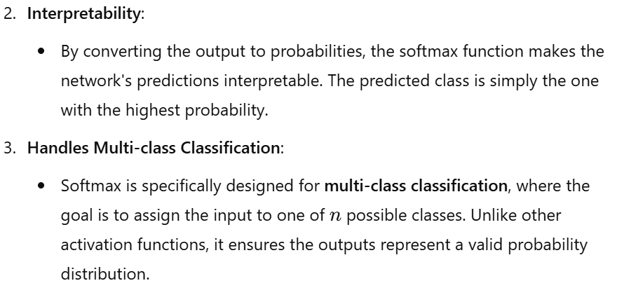

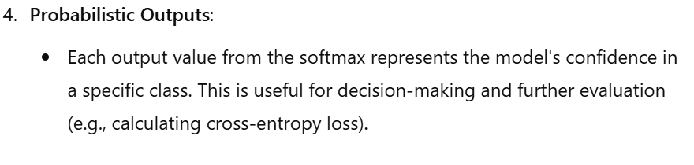

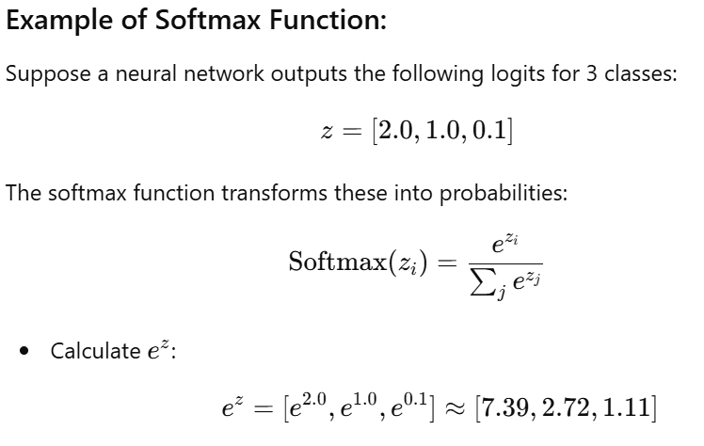

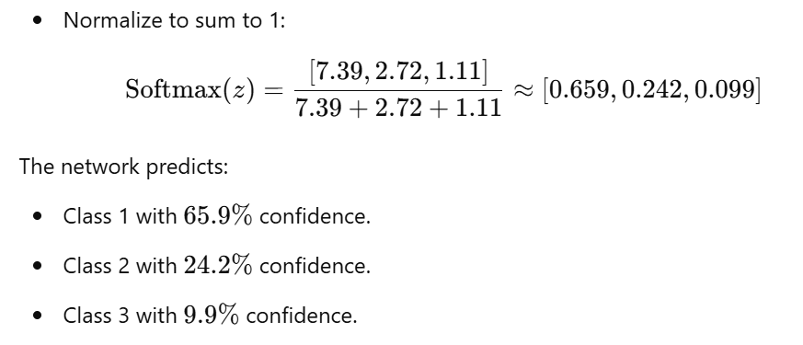

**Q6. What is the purpose of backward propagation in a neural network?**

**Purpose of Backward Propagation in a Neural Network**

**Backward propagation** (or backpropagation) is a method used in neural networks to **update the model's weights and biases** based on the error in predictions. It computes the gradients of the loss function with respect to the weights and biases and propagates these gradients backward through the network.

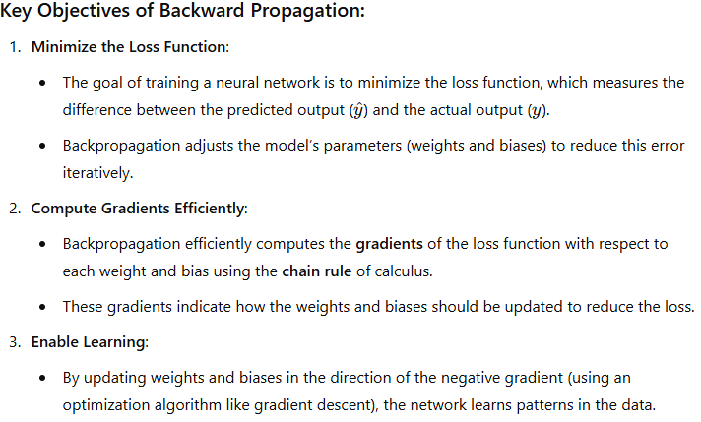

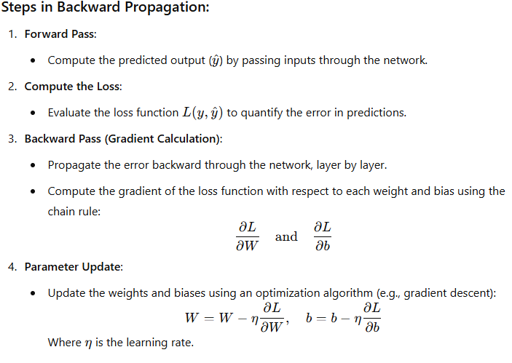

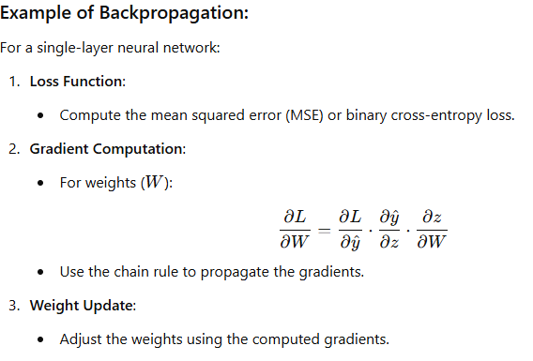

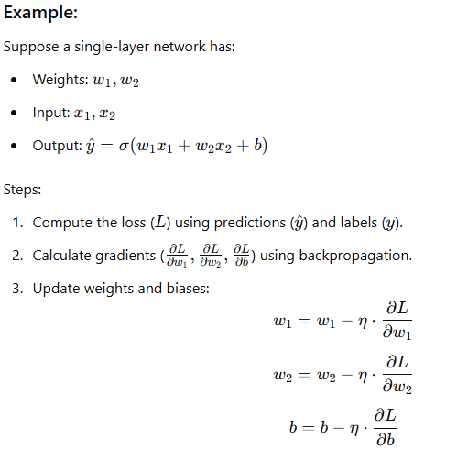

**Importance of Backward Propagation:**

1. **Enables Learning**:
   * Backpropagation is the core algorithm that allows neural networks to learn from data by iteratively reducing the error.
2. **Optimizes Parameters**:
   * It computes precise updates for weights and biases to ensure efficient convergence.
3. **Supports Deep Architectures**:
   * Backpropagation allows learning in deep networks with multiple layers by systematically propagating errors.

**Q7. How is backward propagation mathematically calculated in a single-layer feedforward neural network?**

**Backward Propagation in a Single-Layer Feedforward Neural Network**

Backward propagation mathematically computes the **gradients of the loss function** with respect to the model's parameters (weights and biases). These gradients are then used to update the parameters to minimize the loss.

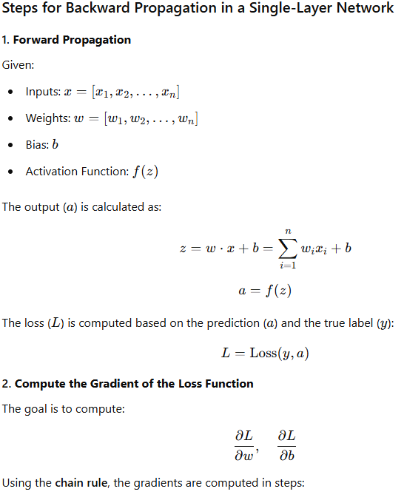

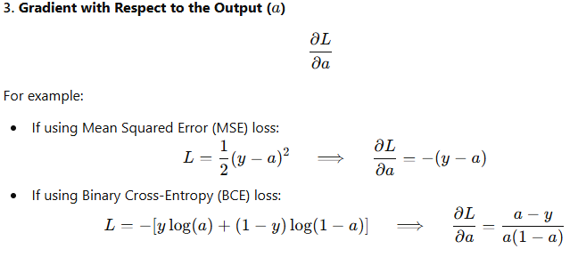

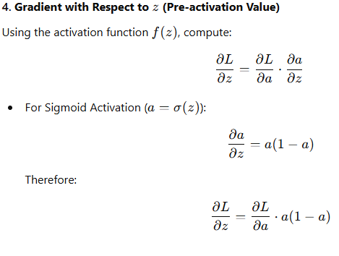

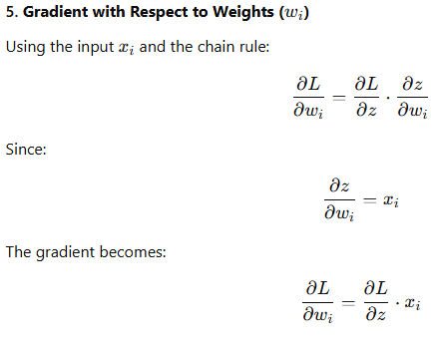

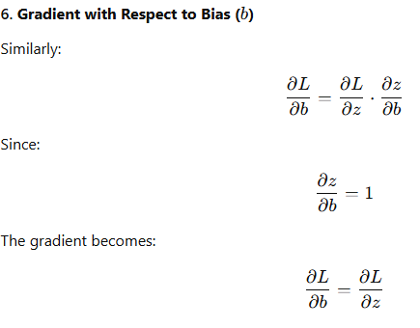

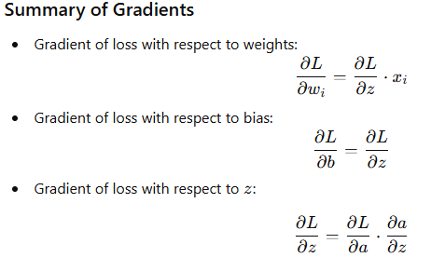

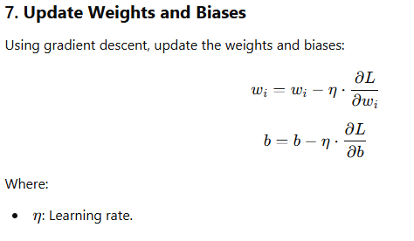

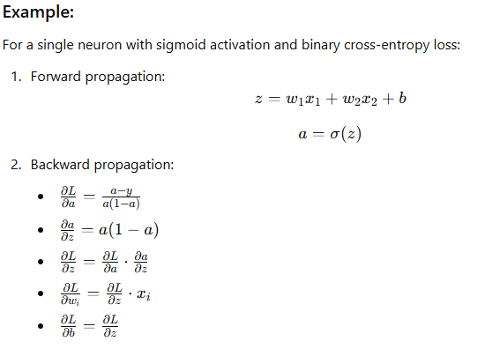

**Q8. Can you explain the concept of the chain rule and its application in backward propagation?**

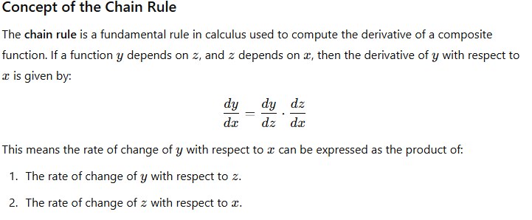

**Application of the Chain Rule in Backward Propagation**

In backward propagation, the **chain rule** is used to compute the gradients of the loss function (LLL) with respect to each parameter (weights and biases) in a neural network. Since the output of one layer is the input to the next, the gradients are calculated by propagating the errors backward through the layers.

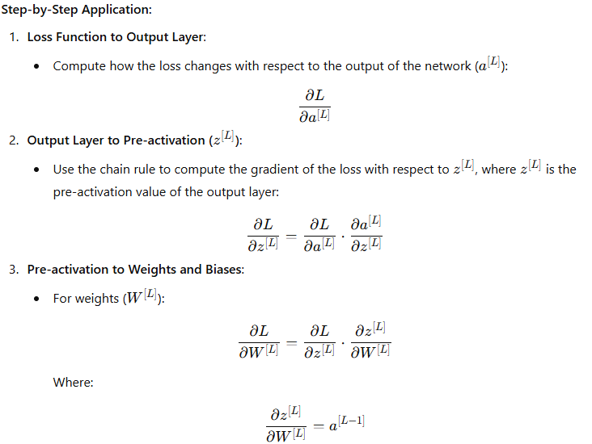

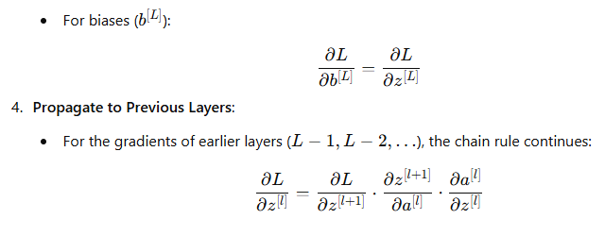

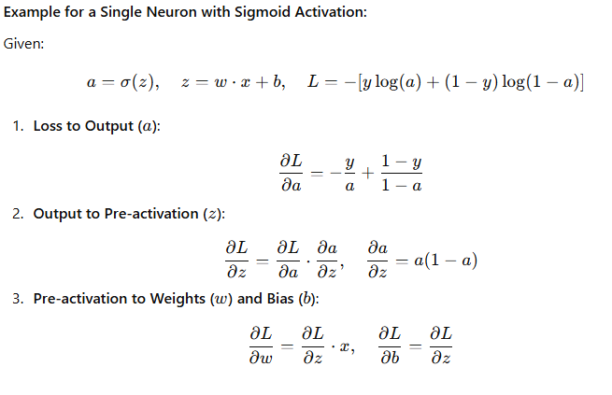

**Why the Chain Rule is Essential for Backpropagation**

1. **Decomposes Complex Gradients**:
   * The chain rule allows the computation of gradients layer by layer, starting from the output and propagating back to the input.
2. **Handles Composite Functions**:
   * Neural networks are composed of multiple layers, each involving a linear transformation and an activation function. The chain rule efficiently computes how changes in parameters at one layer affect the final loss.
3. **Enables Efficient Training**:
   * By computing gradients using the chain rule, backpropagation updates parameters in a computationally efficient manner, even for deep networks.

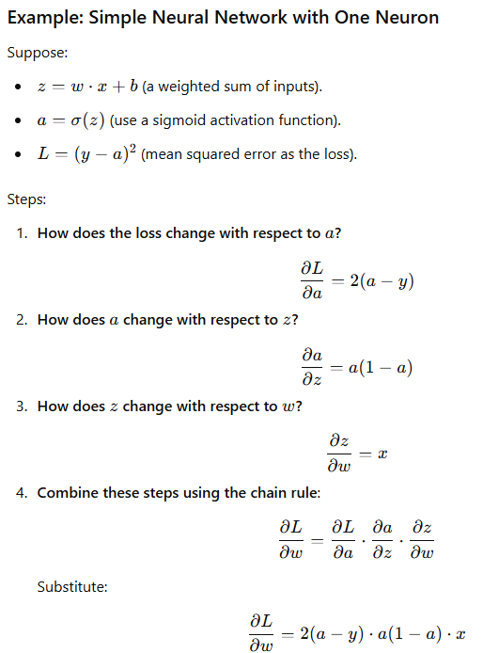

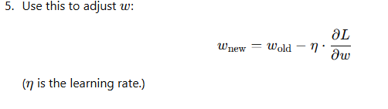

**Q9. What are some common challenges or issues that can occur during backward propagation, and how can they be addressed?**

**Summary Table of Challenges and Solutions:**

|  |  |
| --- | --- |
| **Challenge** | **Solution** |
| Vanishing Gradients | Use ReLU, batch normalization, gradient clipping. |
| Exploding Gradients | Use gradient clipping, proper initialization, advanced optimizers. |
| Overfitting | Apply regularization, dropout, or early stopping. |
| Slow Convergence | Use learning rate schedulers, batch normalization, advanced optimizers. |
| Imbalanced Datasets | Use class weighting, oversampling, undersampling, or synthetic data. |
| Numerical Instability | Use proper initialization, floating-point precision. |
| Poor Initialization | Use Xavier/He initialization or pre-training. |
| RNN Gradient Issues | Use LSTMs/GRUs, truncated backpropagation. |
| Overcomplex Networks | Simplify architecture, use pruning. |

**Common Challenges in Backward Propagation and Their Solutions**

Backward propagation is essential for training neural networks, but it can encounter several challenges that affect learning efficiency and accuracy. Below are the most common issues and practical solutions:

**1. Vanishing Gradients**

**Problem:**

* In deep networks, gradients can become very small (close to zero) as they propagate backward through many layers.
* This happens especially when activation functions like sigmoid or tanh are used, as their derivatives are small for large input values.
* Small gradients make it difficult for weights in earlier layers to update effectively, slowing or halting learning.

**Solution:**

* **Use ReLU or its variants**:
  + Replace sigmoid/tanh activations with ReLU (Rectified Linear Unit), which has a gradient of 1 for positive inputs and avoids vanishing gradients.
* **Use Batch Normalization**:
  + Batch normalization normalizes inputs to each layer, helping maintain gradients within a manageable range.
* **Gradient Clipping**:
  + Limit the gradients to a predefined range to prevent them from becoming too small.

**2. Exploding Gradients**

**Problem:**

* In very deep networks, gradients can grow exponentially during backpropagation, leading to very large updates to weights, making the model unstable.

**Solution:**

* **Gradient Clipping**:
  + Clip gradients to a maximum value to prevent them from growing too large.
* **Use Proper Initialization**:
  + Initialize weights using techniques like Xavier or He initialization to ensure gradients remain stable.
* **Use Optimizers with Adaptive Learning Rates**:
  + Optimizers like Adam and RMSprop adjust the learning rate dynamically to handle large gradients.

**3. Overfitting**

**Problem:**

* The model learns the training data too well, including noise, and performs poorly on unseen data.

**Solution:**

* **Regularization**:
  + Use techniques like L1/L2 regularization to penalize large weights.
* **Dropout**:
  + Randomly deactivate neurons during training to prevent reliance on specific features.
* **Early Stopping**:
  + Monitor validation loss and stop training when it stops improving.

**4. Slow Convergence**

**Problem:**

* Training can be very slow, especially in networks with poor initialization or suboptimal learning rates.

**Solution:**

* **Learning Rate Schedulers**:
  + Dynamically adjust the learning rate during training. For example, reduce the learning rate when the validation loss plateaus.
* **Optimizers**:
  + Use advanced optimizers like Adam, RMSprop, or Adagrad, which are faster and more efficient than vanilla SGD.
* **Batch Normalization**:
  + Normalize inputs to layers, speeding up convergence.

**5. Imbalanced Datasets**

**Problem:**

* If one class dominates the dataset, the model may become biased toward predicting the majority class.

**Solution:**

* **Class Weighting**:
  + Assign higher weights to the minority class during loss calculation.
* **Oversampling or Undersampling**:
  + Balance the dataset by oversampling the minority class or undersampling the majority class.
* **Synthetic Data Generation**:
  + Use techniques like SMOTE (Synthetic Minority Oversampling Technique) to create synthetic examples of the minority class.

**6. Numerical Instability**

**Problem:**

* Gradients can overflow or underflow due to very large or very small weight updates.

**Solution:**

* **Use Proper Initialization**:
  + Initialize weights using techniques like Xavier or He initialization.
* **Precision Control**:
  + Use floating-point precision (e.g., float32) to handle very large or very small numbers.

**7. Poor Weight Initialization**

**Problem:**

* Improper weight initialization can lead to slow learning or failure to converge.

**Solution:**

* **Use Standard Weight Initialization**:
  + Use Xavier initialization for sigmoid/tanh activations or He initialization for ReLU activations.
* **Pre-training**:
  + Pre-train weights using techniques like autoencoders or transfer learning.

**8. Lack of Gradient Flow in Recurrent Neural Networks (RNNs)**

**Problem:**

* RNNs often suffer from vanishing or exploding gradients because they process data sequentially over many time steps.

**Solution:**

* **Use Gated Architectures**:
  + Replace vanilla RNNs with LSTMs (Long Short-Term Memory) or GRUs (Gated Recurrent Units), which are designed to handle long-term dependencies.
* **Truncated Backpropagation Through Time**:
  + Limit the number of time steps used in backpropagation to prevent gradients from becoming unstable.

**9. Overcomplex Networks**

**Problem:**

* Deep networks with too many parameters can make training inefficient and prone to overfitting.

**Solution:**

* **Reduce Network Complexity**:
  + Simplify the architecture by reducing the number of layers or neurons.
* **Pruning**:
  + Remove less important neurons after training to reduce complexity without significant loss in performance.